**GIT Code Check-in Process (RIGHT Suite)**

**Note:** some times, there will be a chance for some files have longer windows paths, which can be not processed by GIT while performing clone operation. To resolve that issue, we need to run below command to properly configure GIT.

**git config --system core.longpaths true**

1. Clone the DB into local machine (first time)

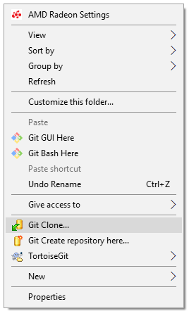

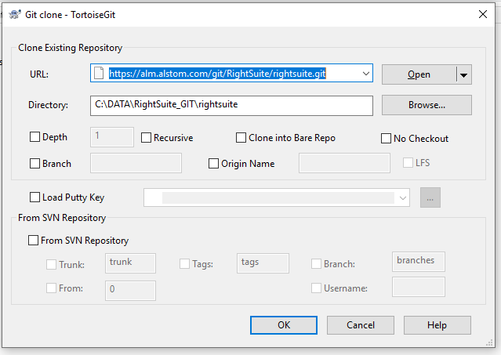

1. Once clone has been created, we can able to see a folder with “green” tick on it.
2. Right click on this folder and perform following action:

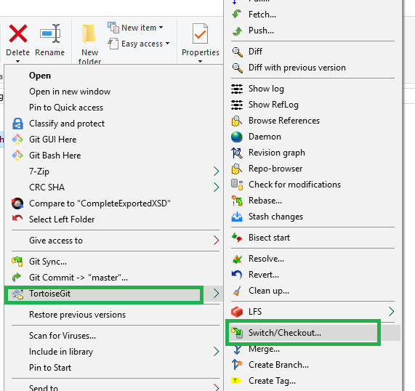

1. The following window shall be displayed

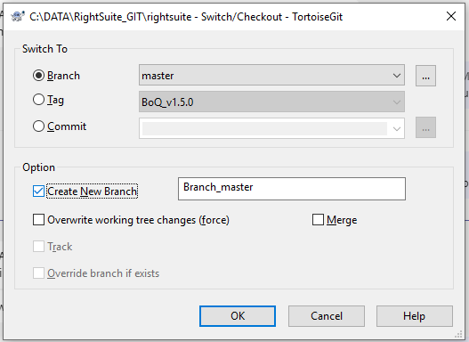

Here, select the “Branch” radio button and choose “master” from the drop down list.

In “Option” section, enable the “Create New Brach” check box and give some name for new branch.

1. A new branch shall be created with the given name.
2. To know the current working branch, right click on the “rightSuite” folder and click on “**GIT Bash Here**” menu.
3. A new command line window will be displayed.
4. Type the following command to know the branches:

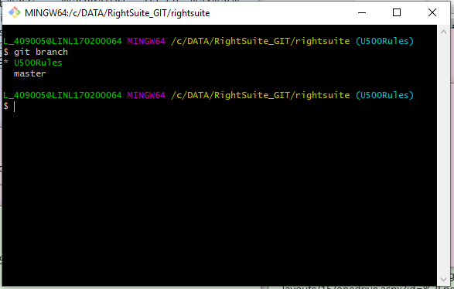

All local branches will be displayed in the command line window and current active branch is displaying in green color. (in our case U500Rules)

Also, in the main path the current active branch is displaying in the parenthesis.(U500Rules)

1. Now, place the **new code** into the local repository folder.
2. Once the code has been placed, again right click on the “rightSuite” folder, and click on “**GIT GUI Here**” menu. Then, following window shall be displayed:

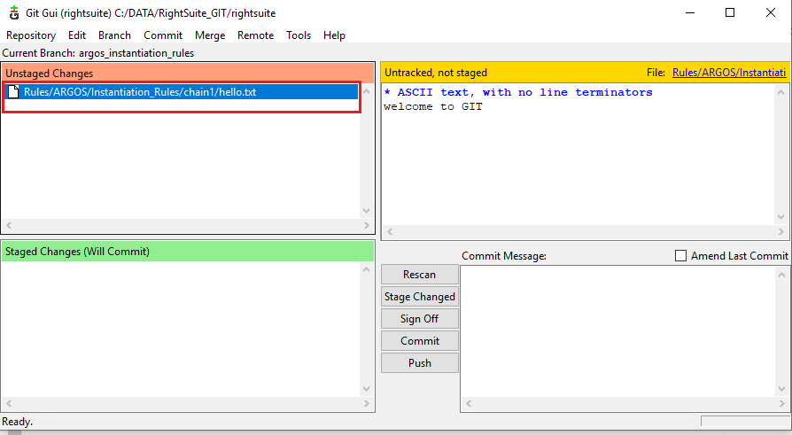

1. All newly added files/folders shall be displayed under “**Unstaged Changes**” section.
2. Now, select the required files/folders from the list, and then run the “**Stage to Commit**” command from “**Commit**” menu as shown in the following figure:

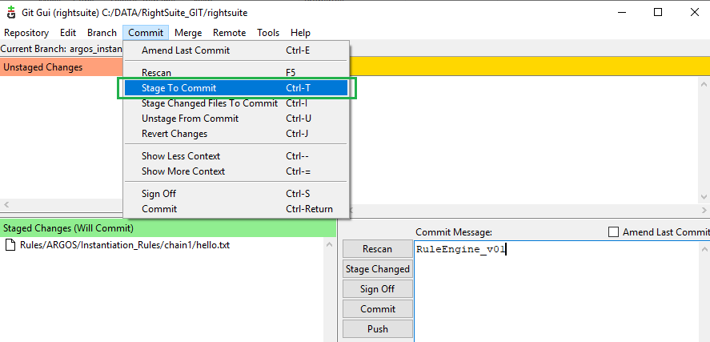

1. Once this operation has been performed, all unstaged files shall be *moved*  to “**Staged Changes**” section as shown in below figure:

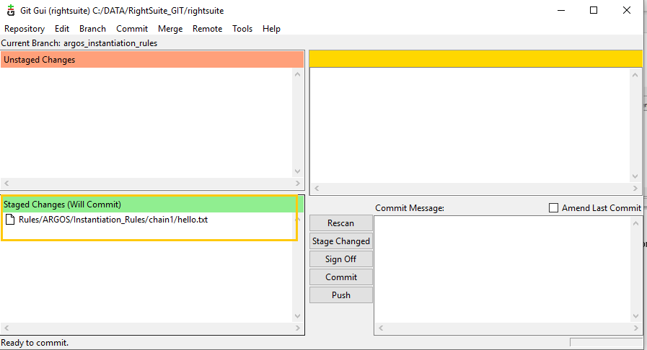

1. Select all files from this section and give some “Commit Message” in the appropriate text box, then click on “**Commit**”button as shown in the following figure:

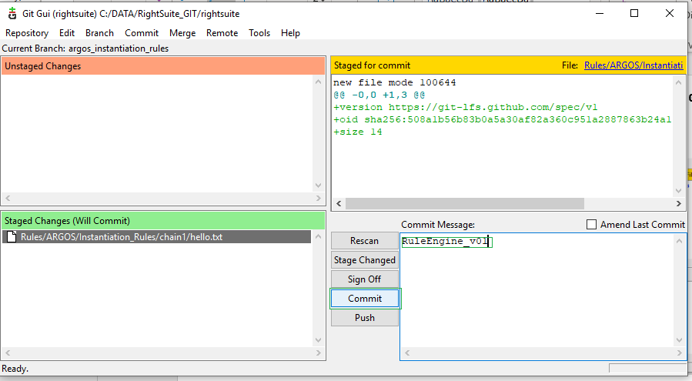

1. Once the commit process done, close this GUI window.
2. Again, right click on the “rightSuite” folder and click on “**GIT Bash Here**” menu and run the following command in order to push the **local** branch into **GIT server**.

**git push origin <local branch name>**

After this command, the code shall be pushed into GIT server successfully.

1. Now, open the GIT url in the web browser and raise a new “Merge Request” to merge the feature “*branch”* code to “*master*” code.